1. Search the link of TCGA: <https://portal.gdc.cancer.gov/> and click “Repository”

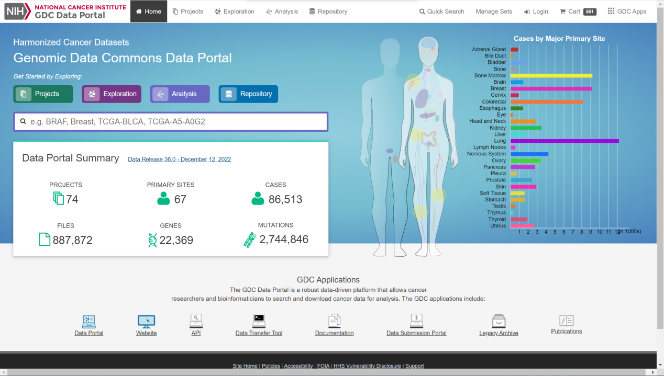

1. Select type of samples: ”Cases”; Primary Site”Bladder”; Program”TCGA”

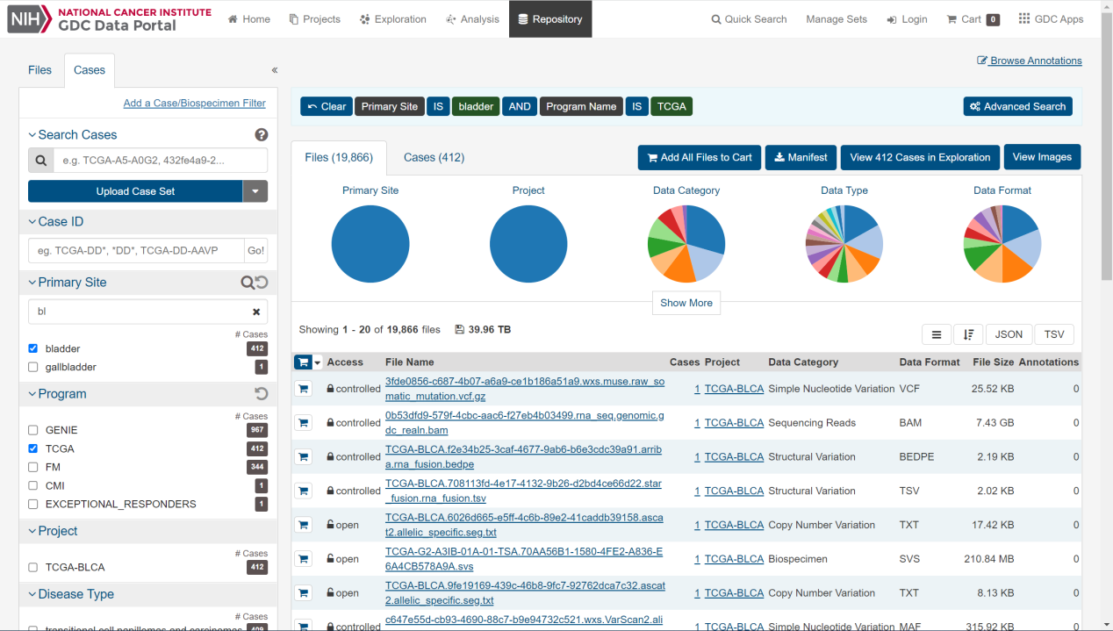

1. Select types of files: “Files”; “transcriptome profiling”; “Gene Expression Quantification”
2. Then click ”Add All Files to Cart”

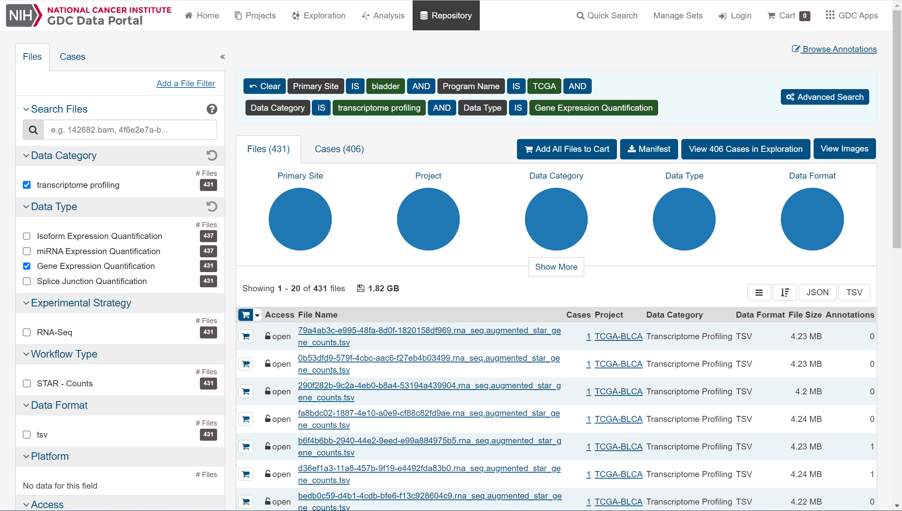

1. Click “Cart” and download the file “**Cart**” and “**Metadata**”

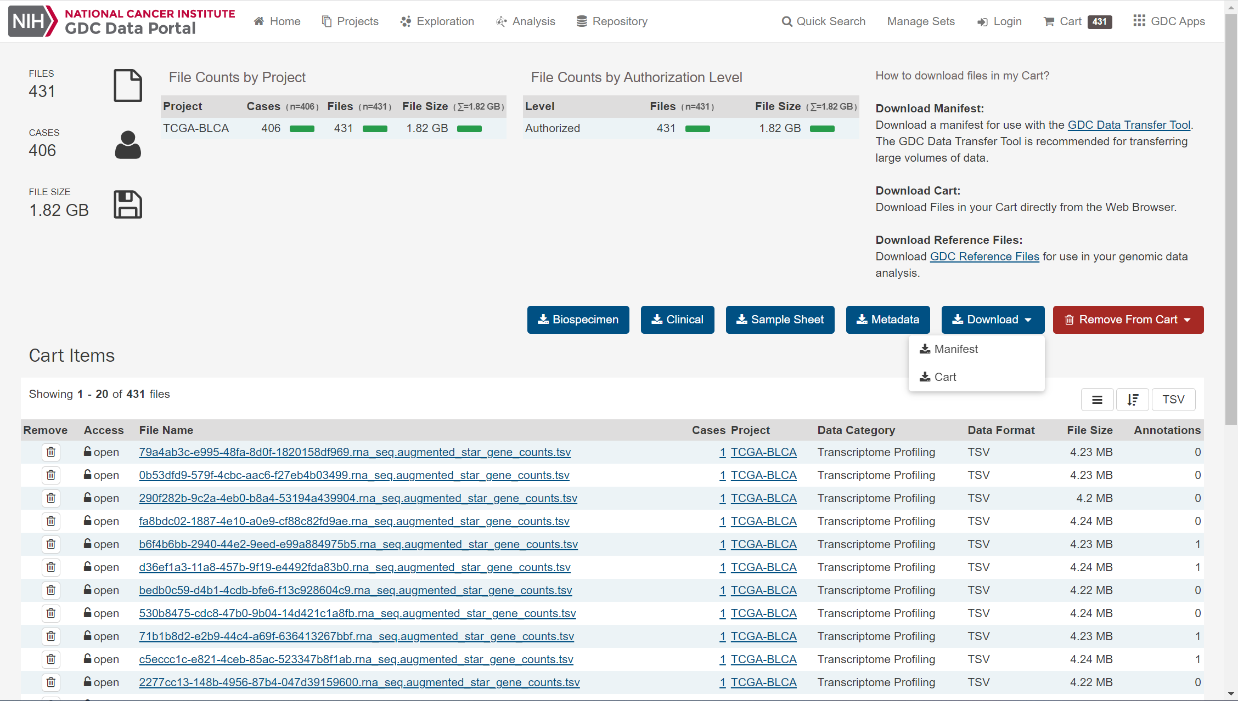

Finally, there documents were downloaded and showed like below:

